Festive Set Menu
£20.00 2 courses
£25.00 3 courses

Starters
Winter warming soup, crusty bread (vg)

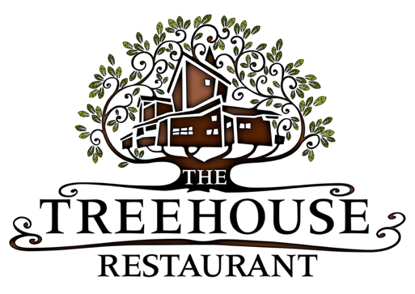
Savoury éclair filled with salmon mousse, pickled beetroot

Local black pudding, pomme puree, red wine jus, crisp onions

Chicken and smoked ham hock terrine, onion chutney, crisp leaves,
toasted sourdough

Mains

Roulade of turkey wrapped in pancetta, sage and onion stuffing, seasonal
vegetables and potatoes, festive trimmings

Mushroom and tarragon gateau, sauteed greens, truffle velouté (vg)

Pan roasted salmon, crushed new potatoes, Cavolo Nero, orange and cranberry butter (gf)

Slow roasted pork belly, fondant potato, honey roasted roots, cider jus (gf)

Desserts
Traditional Christmas pudding, Alnwick rum sauce

Vegan key lime pie, poached raspberries (vg)

Treacle tart, clotted cream ice cream

Dark chocolate cheesecake, mulled wine winter berries

