Potting Shed Menu

Tree House Burger
Aberdeen Angus burger with smoked bacon, mature cheddar cheese,
homemade burger sauce
£9.95

Fish Finger Ciabatta
Fish goujons with tartare sauce and baby gem lettuce
£8.95

Steak and Cheese Ciabatta
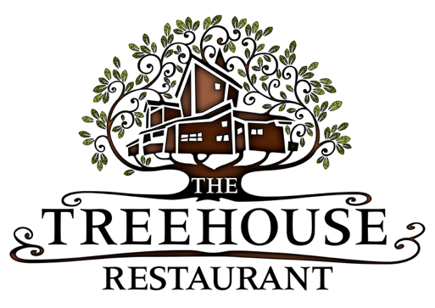
Grilled steak, roasted peppers, grilled onion, cheddar cheese and mustard mayo £10.95

Mediterranean Vegetables and Goats Cheese Ciabatta (v)
Roast Mediterranean vegetables topped with grilled goats’ cheese
and basil mayo £7.95

Add fries to the above hot sandwiches £2.50

Sides £2.95
Seasoned fries
Hand cut chips
Onion rings
Coleslaw
Caesar salad

