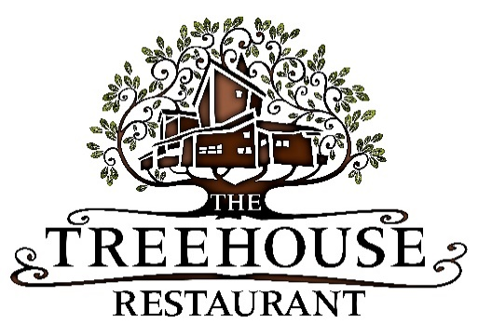

Treehouse Kids Menu

Local pork sausage, creamed potatoes, seasonal greens, gravy £5.95
Penne pasta, rich tomato sauce, garlic bread £4.50
Chicken supreme, thick cut chips, peas, gravy £5.95
Battered fish finger, thick cut chips, crushed peas £5.95
Sunday Lunch £7.50*

Desserts £3.50

Chocolate Brownie with ice-cream
Banana Split
Ice-Cream Selection

*available Sunday’s only

